# CS 255 System Design Document Template

## UML Diagrams

### UML Use Case Diagram

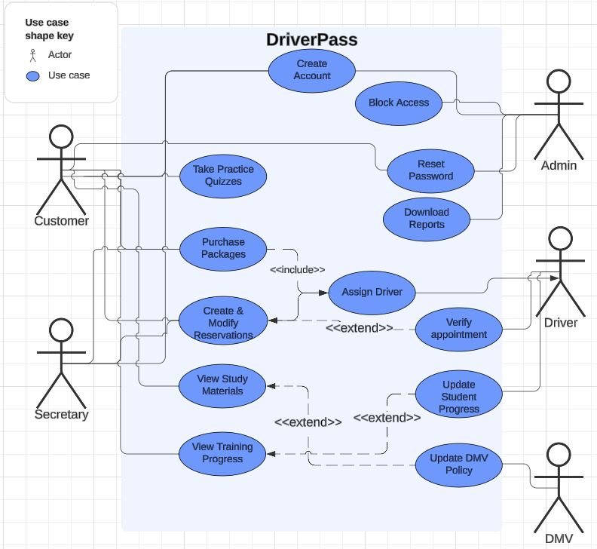

### UML Activity Diagrams

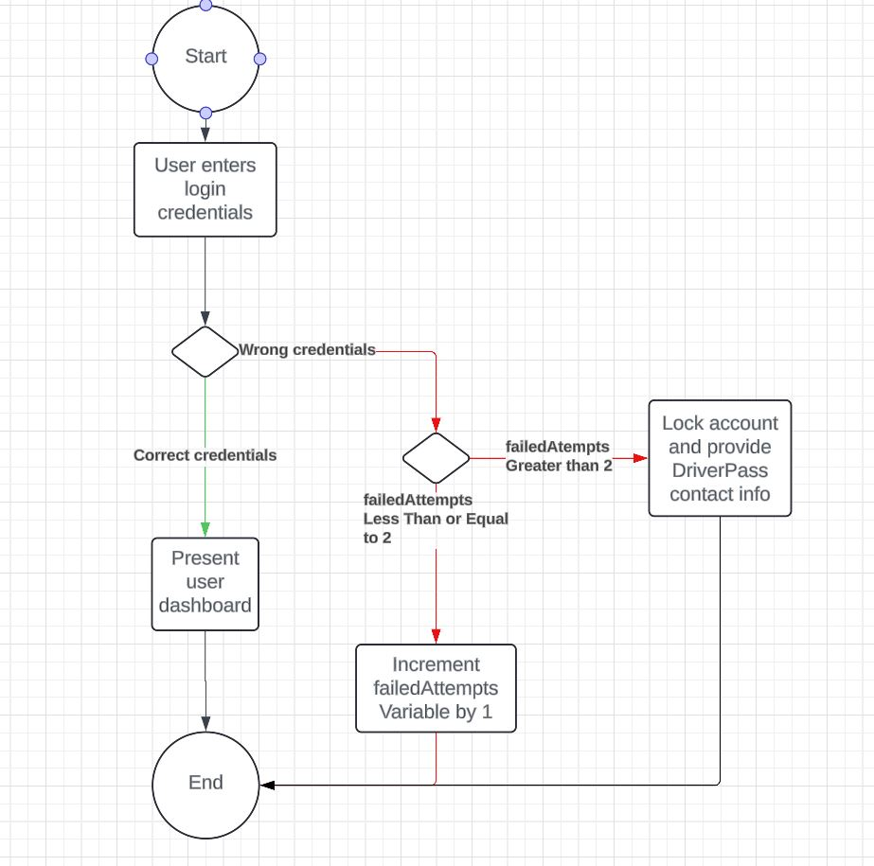

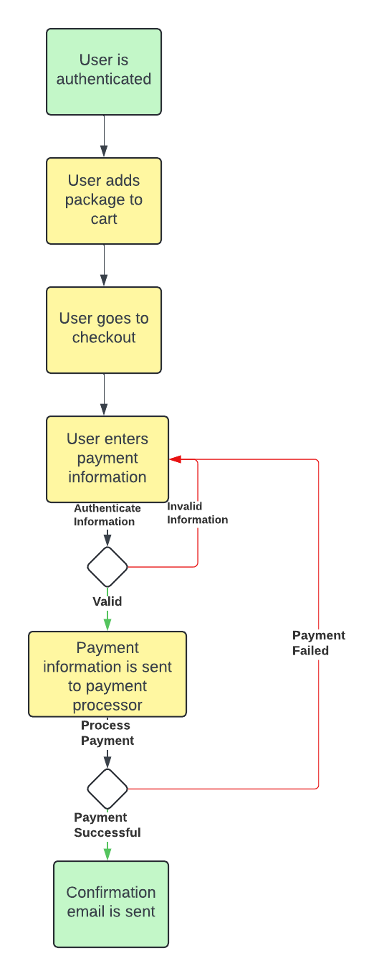

### UML Sequence Diagram

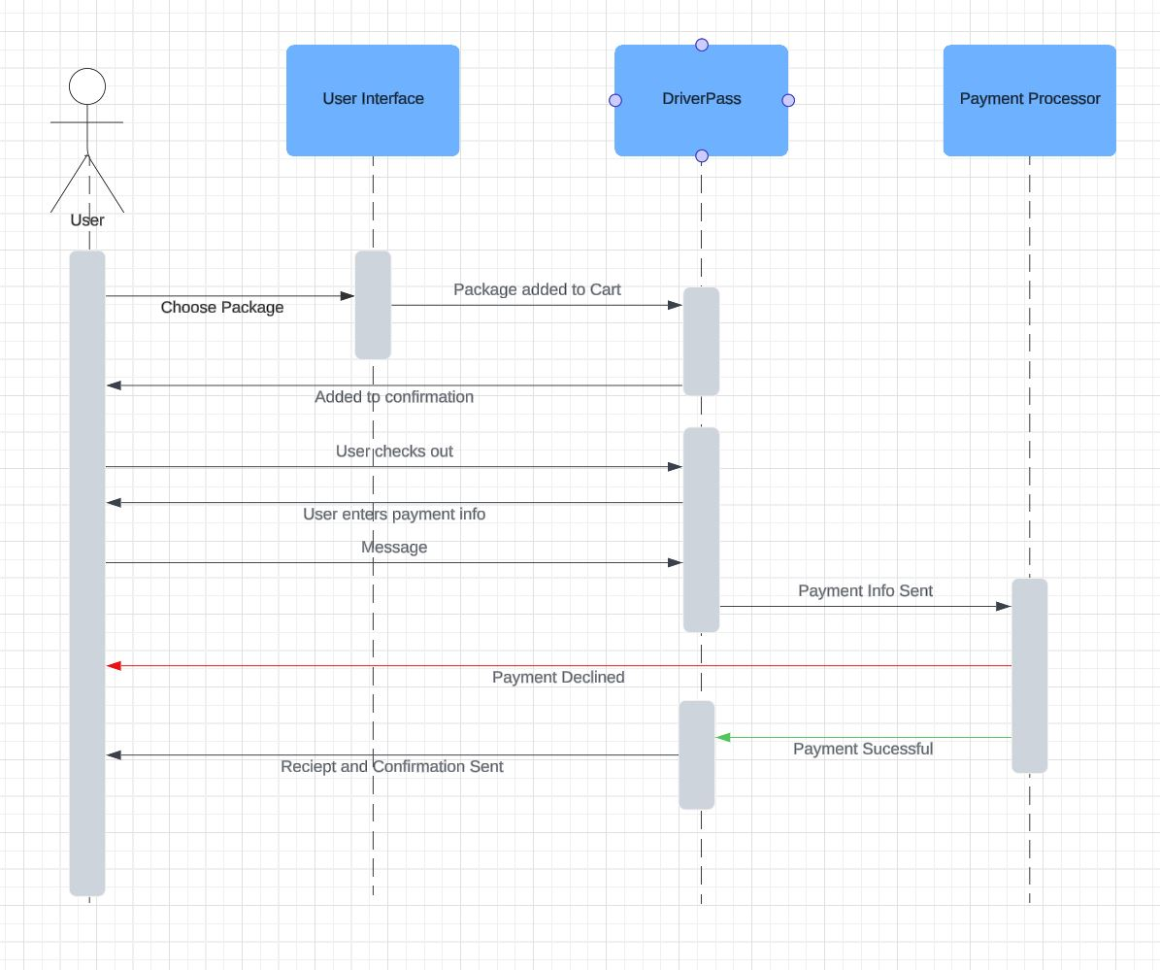

### UML Class Diagram

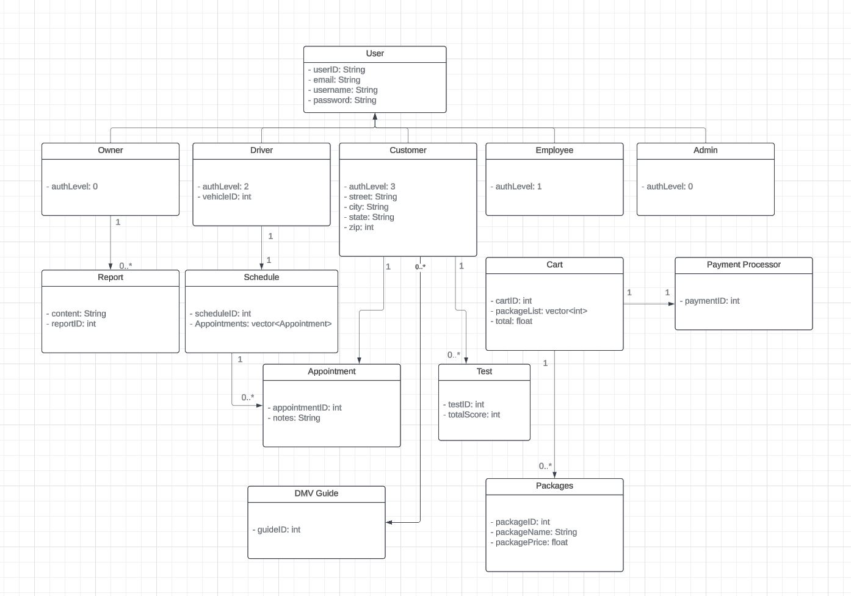

## Technical Requirements

* Hardware Requirements
  + Dedicated servers
  + Powerful server hardware
  + Ample storage in the server racks
  + Firewalls and safety precautions built into servers
  + Computer or mobile phone for user connection
  + Fast and reliable internet connection
* Software Requirements
  + Utilize Linux based server for stability and lower resource usage
  + Deployment of an SQL database with CRUD implementation
  + Implement server encryption
* Tools
  + CRUD operation using MongoDB